TASK 6 ATAR CHEMISTRY UNITS 1 & 2

RESEARCH ASSIGNMENT QUIZ 2 ANSWER SHEET

SHE 5 - Aqueous solutions and acidity

(TEST 3 Part A) (25 marks)

1. Chlorination is used to purify water and make it possible to drink.

Briefly explain why and how this process is carried out. (4 marks)

1. The diagram below shows one method that can be used to purify water.

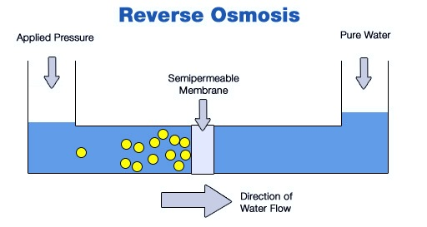

1. What is the name of the treatment process that uses this method?

(1 mark)

b) Explain the steps in this treatment process. (5 marks)

1. a) Give two examples of heavy metals often found in drinking water?

(2 marks)

1. What is an acceptable level of these heavy metals for the water to be

considered safe to drink? (3 marks)

1. Briefly describe how they reduce these heavy metals to bring them

to an acceptable drinking level. (2 marks)

d) How is this method influenced by social and economic factors?

(2 marks)

4. a) Why is water fluorinated? (2 marks)

b) In what form is fluoride that is added to water in Australia?

Give the name and formula (2 marks)

c) At what level is it added to our water? (2 marks)

END OF PART A